Time-Based Coffee Shop Menu Recommendation System Using K-Nearest Neighbor

Yusuf Herfa Auliansyah¹, Yusuf Mansur¹, Rizqi Nuzul Firman¹, Findi Ayu Sariasih¹, Jajang Jaya Purnama¹, Khoirun Nisa²

¹Informatics Study Program; ²Management Study Program
Universitas Bina Sarana Informatika (UBSI), Kaliabang Campus, Bekasi, Indonesia
15240075@bsi.ac.id; 15240047@bsi.ac.id; 15240116@bsi.ac.id; findi.fav@bsi.ac.id; jajang.jjp@bsi.ac.id; khoirun.khn@bsi.ac.id

Abstract

Coffee shops that show every customer the same long menu at every hour give little guidance, although what people order and how busy the shop is may change through the day. This study builds a time-based menu recommendation and an hourly crowd prediction for Lower Manhattan Coffee Shop using K-Nearest Neighbor (KNN), served by a Flask service to a CodeIgniter 4 ordering application with a rule-based fallback. We used the public Coffee Shop Sales dataset, which describes a fictitious shop, with 47,782 transactions of one branch, and compared the models with simple baselines on random, temporal, and forward-chaining splits. Time explained the product category only negligibly (Cramér's V = 0.034). KNN with K = 20 reached 35.31% accuracy, below the 38.10% of the majority baseline, and its top-3 category hit rate (77.83%) was below that of the three most frequent categories (83.73%). Hourly crowd prediction beat the hourly mean on a random split (mean absolute error 6.15 against 7.42), but on June, a month not seen in training, a last-month baseline was better (8.14 against 8.72). For three crowd levels, KNN did not beat the hour-mode baseline on the temporal split (macro F1-score 57.31% against 65.93%). The evaluation is offline and covers categories, not item ranking or user acceptance, so KNN is not shown to improve on simple baselines, and validation with real transactions is needed.

Keywords: recommendation system; K-Nearest Neighbor; time-based; coffee shop; crowd prediction

Abstrak
Coffee shop yang menampilkan daftar menu panjang yang sama pada setiap jam kurang membantu pelanggan, padahal apa yang dipesan dan tingkat keramaian dapat berubah sepanjang hari. Penelitian ini membangun rekomendasi menu berbasis waktu dan prediksi keramaian per jam untuk Lower Manhattan Coffee Shop menggunakan K-Nearest Neighbor (KNN), dilayani oleh layanan Flask kepada aplikasi pemesanan CodeIgniter 4 dengan mekanisme cadangan berbasis aturan. Kami memakai dataset publik Coffee Shop Sales yang menggambarkan toko fiktif, dengan 47.782 transaksi dari satu cabang, lalu membandingkan model dengan baseline sederhana pada pembagian acak, temporal, dan validasi maju. Waktu hanya menjelaskan kategori produk secara dapat diabaikan (Cramér's V = 0,034). KNN dengan K = 20 mencapai akurasi 35,31%, di bawah baseline mayoritas sebesar 38,10%, dan tingkat ketepatan kategori top-3-nya (77,83%) di bawah tiga kategori terbanyak (83,73%). Prediksi keramaian per jam mengungguli rata-rata per jam pada pembagian acak (galat absolut rata-rata 6,15 terhadap 7,42), tetapi pada Juni, bulan yang tidak terlihat saat pelatihan, baseline bulan terakhir lebih baik (8,14 terhadap 8,72). Untuk tiga tingkat keramaian, KNN tidak mengalahkan baseline modus per jam pada pembagian temporal (F1-score makro 57,31% terhadap 65,93%). Evaluasi bersifat offline dan mencakup kategori, bukan peringkat item atau penerimaan pengguna, sehingga KNN belum terbukti lebih baik daripada baseline sederhana dan validasi dengan transaksi nyata diperlukan.

Kata kunci: sistem rekomendasi; K-Nearest Neighbor; berbasis waktu; coffee shop; prediksi keramaian

INTRODUCTION

A coffee shop with a long menu gives customers many choices but little guidance, and the items that sell well at breakfast are rarely the ones that sell well near closing time. Lower Manhattan Coffee Shop, the case of this study, offers 80 menu items in nine categories, from coffee, tea, and bakery items to packaged beans. Customers scan a QR code at their table to order without creating an account, and the cashier handles payment and stock through the same application. Digital ordering is already reaching small coffee shops. (Arisandi et al. 2024) replaced handwritten order records at a coffee shop with an ordering application, and (Salam et al. 2026) describe a QR-based self-ordering system at a warkop, a small Indonesian coffee stall. (Pratama and Dewi 2025) mined the sales records of a coffee shop with the Apriori algorithm to understand purchasing patterns. These works cover ordering, record keeping, and item associations, but not what the menu should highlight at a given hour. In the application, the menu is shown in the same order all day, so a customer who wants a suggestion has to scroll through the whole list.
Recommender systems are the usual answer to this problem. (Meng et al. 2022) survey context-aware recommender systems and the way they are evaluated, and (Bogina et al. 2023) survey how temporal aspects such as the time of day are used in recommendation. For food, (Bondevik et al. 2024) reviewed 67 studies and found that food recommender systems vary widely, mostly rely on content-based filtering and machine learning, and often give non-personalized suggestions. (Chow et al. 2023) reached a similar picture in their review of techniques, datasets, and evaluation metrics. Among time-aware work, (Panwar et al. 2024) built a food recommender with a support vector machine that combines the time of day with a weekend multiplier, and they report better error values than a rule-based baseline. Their setting is different from a QR ordering application, however. It predicts ratings for individual users, while a table-ordering application usually has no customer accounts and its orders are anonymous. A non-personalized recommendation that depends on when the customer orders is therefore more realistic here.
The K-Nearest Neighbor (KNN) algorithm is a reasonable fit for this setting. It classifies an item by the labels of its closest examples, needs no complicated training step, and its decisions can be explained to a shop owner by pointing to similar past orders. (Hssina et al. 2021) combined KNN with singular value decomposition to address the cold start problem in a collaborative filtering recommender. Indonesian studies have also applied KNN to food businesses. (Sari et al. 2025) used KNN with k = 3 on one year of sales data from a Padang restaurant to classify how well each menu item sells and reported 95.45% accuracy. (Nafi and Mujiyono 2025) used KNN to suggest daily meals from nutritional values and user preferences, and (Mellany and Kusnawi 2026) combined popularity ranking, TF-IDF with KNN, and tag-based similarity to recommend menu items from about 77,000 transactions of a small restaurant. (Rizki et al. 2024) used Apriori to recommend menu bundles from restaurant transactions. These studies rely on sales classification, nutrition, item similarity, or association rules. Among the studies reviewed here, none takes explicit time-of-day segments as the basis of the recommendation.
KNN also has two sensitive choices that this study has to handle. The first is feature scaling. (Allorerung et al. 2024) compared normalization methods for KNN on three disease datasets and found that the best method depended on the dataset. The second is the number of neighbors K. Earlier studies used k-fold cross-validation to examine KNN performance and to select K (Hafid 2023; Pratama and Mandita 2024), and a further study (Taslim et al. 2022) reported a modest accuracy of about 56.67% with K = 5 on a small student dataset. We therefore standardize the features and select K by cross-validation instead of fixing it in advance.
This study also faces a data limit. Lower Manhattan Coffee Shop has no history of real transactions yet, so the models are trained on the public Coffee Shop Sales dataset from Maven Analytics, which describes a fictitious coffee shop with three branches. (Figueira and Vaz 2022) review methods for generating synthetic data and assessing its quality, and (Hidasi and Czapp 2023) show that flawed offline evaluation setups are common in recommender systems research. Both are reminders that results on simulated data need careful reading and comparison with simple baselines. A further question follows. If what customers order depends only weakly on the hour, a time-based menu recommendation has little to learn, whereas the number of transactions per hour may still follow a clear daily pattern. We therefore pair the menu recommendation with a crowd prediction, and we report both against baselines so that the contribution of KNN is not overstated.
The objectives of this study are (1) to design a time-based menu recommendation that uses KNN with four time segments, namely morning (06.00-10.59), afternoon (11.00-14.59), evening (15.00-17.59), and night (18.00-20.59); (2) to predict the number of transactions per hour with KNN regression and to label each hour as busy, moderate, or quiet; (3) to integrate both models into the ordering application through a Flask service, following the model deployment approach (Suherlan et al. 2025), and a CodeIgniter 4 API, with a rule-based fallback when the service is unavailable; and (4) to evaluate the models with accuracy, macro F1-score, mean absolute error, and R² against simple baselines. The expected benefit is a shorter path from opening the menu to ordering for customers, and a clearer view of time-dependent demand for the owner.

RESEARCH METHODS
Types of Research
This research is applied quantitative research with two parts. The first part is system development: a time-based recommendation service is built and connected to a table-ordering web application. The second part is an offline experiment: two K-Nearest Neighbor (KNN) models are trained and evaluated on secondary transaction data and compared with simple baselines. The research does not collect data from customers, and it does not test the system with live users.
Time and Place of Research
The system development and the data analysis were carried out from October to November 2026 at the Informatics Study Program, Universitas Bina Sarana Informatika (UBSI), Kaliabang Campus, Bekasi, Indonesia. The transactions analyzed were recorded from 1 January to 30 June 2023 (181 days) at the Lower Manhattan branch of a fictitious coffee shop.
Research Target / Subject
The data come from the public Coffee Shop Sales dataset published by Maven Analytics under a public domain license (Maven Analytics n.d.). The publisher describes the shop as fictitious, so the data do not record real customers. The file has 149,116 transactions from three branches and 11 attributes: transaction ID, date, time, quantity, store ID, store location, product ID, unit price, product category, product type, and product detail. This study uses only the Lower Manhattan branch (store ID 5), which has 47,782 transactions, 80 products, and nine product categories. Figure 1 shows how the average number of transactions changes during the day. The two other branches are excluded so that the models describe one shop. No sampling is applied, and all 47,782 transactions of the branch are used. Transactions after 19.00 are recorded on only 16 of the 181 days, so the opening hours of the shop cannot be read from the data. The dataset has no customer or basket identifier, so the study cannot analyze individual customers or items bought together.
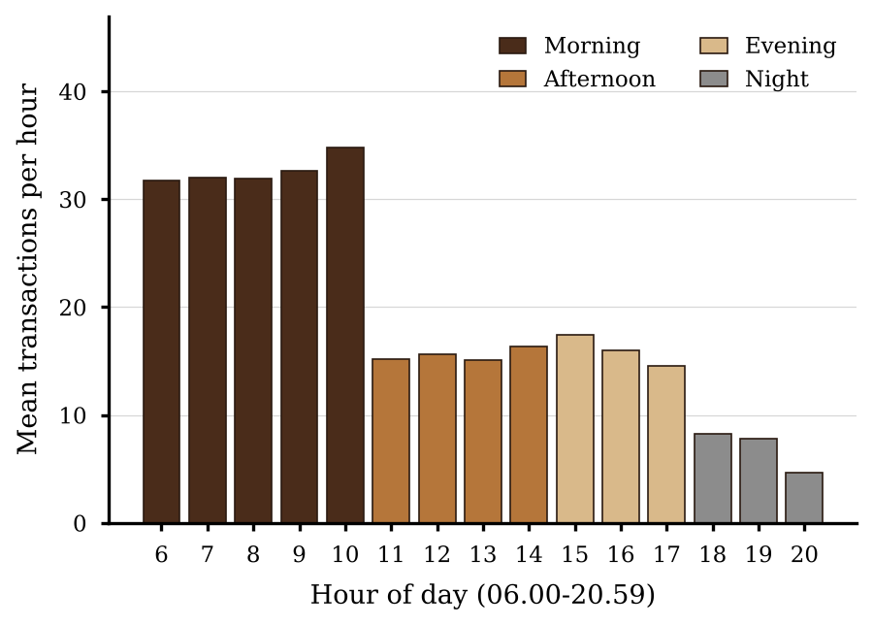
Figure 1. Mean Number of Transactions per Hour at the Lower Manhattan Branch, January-June 2023

Procedure
The research follows seven steps, summarized in Figure 2.
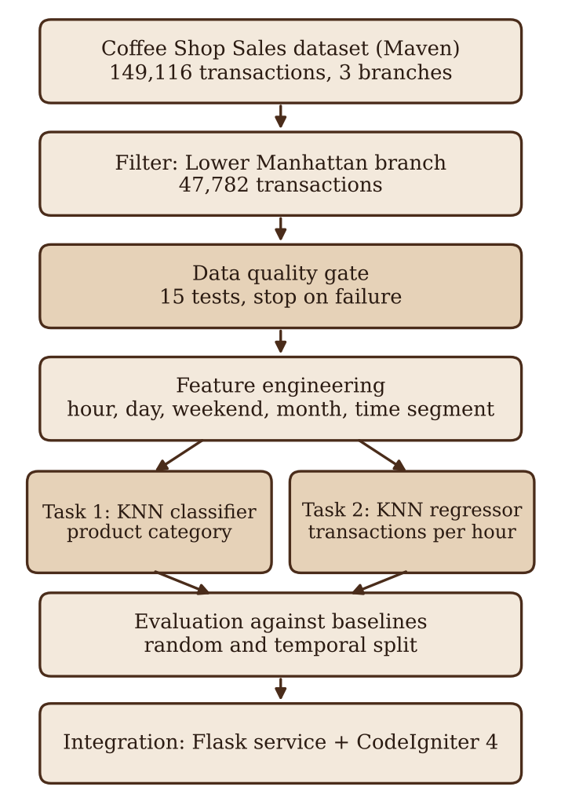
Figure 2. Research Procedure

(1) Data quality testing. Before any modeling, the data go through 15 checks that are recorded in an audit report: file integrity (SHA-256), schema, missing values, duplicates, date and time validity, numeric ranges and outliers, categorical and price consistency, transaction ID gaps, operating hours, class balance, monthly trend, dependence on time, target leakage, and row reconciliation. A missing file, sheet, or schema stops the pipeline. Outliers that are legitimate, such as the high price of coffee beans, are counted and kept.
(2) Feature engineering. The hour, the day of the week, a weekend indicator, and the month are taken from the transaction time and date. The hour is also encoded as a sine and cosine pair, which complements the raw hour with a smooth daily cycle; the shop operates from 06.00 to 20.59, so the cycle does not wrap within opening hours. The operating day is divided into four time segments: morning (06.00-10.59), afternoon (11.00-14.59), evening (15.00-17.59), and night (18.00-20.59). Requests outside these hours are handled by a fallback message. Product ID, unit price, product type, and product detail are not used as features of the category model, to prevent target leakage. Table 1 lists the features of each model.
Table 1. Features Used by Each Model
Feature | Description | Task 1 | Task 2
Hour | Hour of the transaction (6-20) | Yes | Yes
Day of week | 0 (Monday) to 6 (Sunday) | Yes | Yes
Weekend indicator | 1 for Saturday and Sunday | Yes | Yes
Month | Month of the year (1-6) | No | Yes
Hour sine and cosine | Cyclic encoding of the hour | Yes | Yes

(3) Menu recommendation model (Task 1). A KNN classifier predicts the product category from the hour, day of the week, weekend indicator, and the sine and cosine of the hour. The best categories are then mapped to the most popular menu items of the current time segment.
(4) Crowd prediction model (Task 2). Transactions are counted for every date and hour. Because the dataset has no customer identifier, the number of transactions per hour is used as a proxy for how busy the shop is. A KNN regressor predicts the number of transactions per hour from the hour, day of the week, weekend indicator, month, and the sine and cosine of the hour. An hour is labeled quiet, moderate, or busy using the first and third quartiles of the training counts, which are 11 and 28 transactions per hour for the random split. Only date-hour slots with at least one transaction are recorded (2,256 of the 2,715 possible slots), and the target is defined over these slots.
(5) System integration. The models are saved with their metadata and served by a Python Flask service on a local port, following the deployment approach (Suherlan et al. 2025). The CodeIgniter 4 application calls the service when a customer opens the menu of a table and shows the recommended items and the crowd label in a widget. If the service is unavailable or returns an invalid result, the application uses a rule-based fallback based on item popularity. Figure 3 shows the architecture. Each shown and selected recommendation is logged without customer identity. The database has tables for users, tables, products and their options, orders, order items, payments, notifications, product activity, settings, aggregated crowd and category data, and recommendation logs.
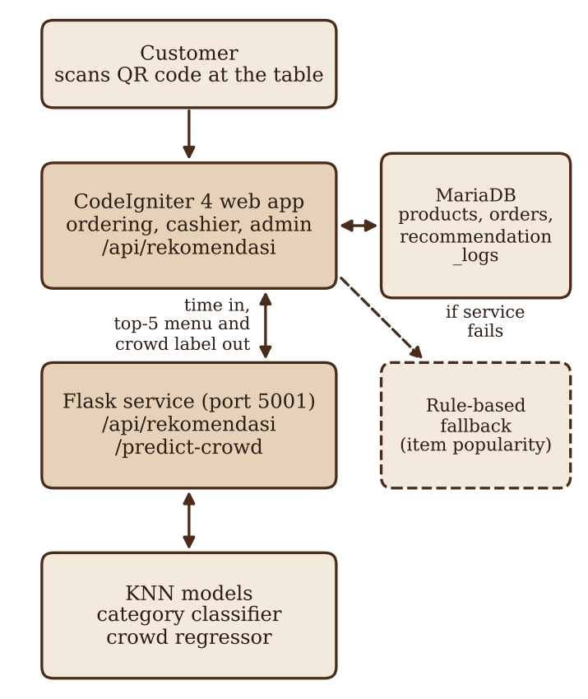
Figure 3. Architecture of the Recommendation System

(6) Evaluation against baselines. Each model is compared with simple baselines that need no learning, so that any gain from KNN can be measured.
(7) Interpretation. The results are read together with the tests of time dependence, and the limits of a simulated dataset are stated.
Data, Instruments, and Data Collection Techniques
The data are secondary quantitative data. The Excel file was downloaded once from the Maven Analytics data playground and was never modified, and its SHA-256 hash is stored so that every later run can be tied to the same file. The instruments are software tools: Python with pandas, NumPy, and scikit-learn for data processing and modeling, Matplotlib for figures, Flask for the model service, and CodeIgniter 4 on PHP 8.2 with MariaDB for the ordering application. The software versions used in training are saved in the model metadata, and random seeds are fixed so that the results can be repeated.
Data Analysis Technique
Features are standardized, because KNN depends on distances and the choice of scaling can change its results (Allorerung et al. 2024). The distance between two records x and y is the Euclidean distance, the square root of the sum of squared differences of all features. For the classifier, K = 20, the value used in the application, is the main setting, and K from 1 to 800 is examined by five-fold cross-validation with accuracy and macro F1-score (Hafid 2023; Pratama and Mandita 2024). For the temporal test, K is selected again using January to May only. For the regressor, K is chosen by the lowest mean absolute error in five-fold cross-validation on the training data only. The feature scaler is placed in a pipeline, so it is fitted on training data only and refitted inside each cross-validation fold. The category labels are converted to integers before the split; this mapping uses no feature information.
For Task 1, the data are split 80:20 with stratification and a fixed seed. A second test trains the model on January to May and tests it on June. The classifier is evaluated with accuracy, macro precision, macro recall, macro F1-score, weighted F1-score, a confusion matrix, and a top-3 category hit rate, which counts a case as correct when the true category is among the three highest-ranked categories. The baselines are the majority category, the most frequent category of each hour-day combination, and, for the top-3 category hit rate, the three most frequent categories of the training data. Confidence intervals are obtained by a bootstrap that resamples dates, because transactions on the same day are correlated. The bootstrap uses 1,000 replicates, resamples dates with replacement, takes the 2.5th and 97.5th percentiles, uses paired differences for comparisons with baselines, and a fixed seed of 42.
For Task 2, the hourly counts are evaluated with mean absolute error and the coefficient of determination (R²); the root mean squared error is also computed and stored with the results. Two splits are used. The first is a random 80:20 split of the date-hour records. The second trains on January to May and tests on June, which is closer to real use because it predicts a month the model has not seen. The temporal split and forward chaining are treated as the main evidence, and the random split is reported for comparison. The baselines are the mean count of each hour, and a seasonal naive baseline that uses the mean count of each hour in the last training month. A third scheme, forward chaining, trains on the months before each test month and tests on March, April, May, and June in turn. A model without the month feature shows how much of the accuracy comes from the growth in volume over the months. Differences from the baselines are summarized with 95% confidence intervals from a bootstrap that resamples dates. Because empty hour slots are probably closed hours, they are left out of the main analysis, and a sensitivity analysis fills them with zero. The hourly counts are also converted into three classes (quiet, moderate, busy) and evaluated with accuracy and macro F1-score against the majority baseline and a baseline that predicts the most frequent class of each hour.
The dependence of the product category on the time segment is tested with the chi-square test of independence and measured with Cramér's V. The dependence of the hourly volume on the hour is tested with the Kruskal-Wallis test. These tests show whether time carries information about what customers order, about how many transactions occur, or both, and they explain why the two tasks are evaluated separately. Because the dataset is simulated, all conclusions are limited to the pipeline and to this dataset, in line with the cautions about synthetic data and offline evaluation raised in earlier work (Figueira and Vaz 2022; Hidasi and Czapp 2023).
All reported metrics come from an offline evaluation notebook that wraps scaling and the model in one pipeline, so that scaling is fitted inside each cross-validation fold. The notebook encodes the hour at the middle of the hour (hour + 0.5) for the sine and cosine features, whereas the deployed service uses the minute-level hour. The deployed model is therefore a separate artifact, trained on the processed data file (model version 2.0.0, stored accuracy 34.89%, top-3 category hit rate 78.83%, and temporal accuracy 34.61%), and its numbers differ slightly from those reported here. The notebook was run on the original Excel file, whose SHA-256 hash differs from that of the processed file used by the service. The item-level ranking, the acceptance of recommendations, and their effect on customers are not tested.

RESULTS AND DISCUSSION
Dependence of Menu and Crowd on Time
The Lower Manhattan data contain 47,782 transactions without missing values or duplicate transaction IDs, so no cleaning was needed. Two tests separate what time can and cannot explain. The product category depends on the time segment only negligibly. The chi-square test is significant (χ² = 161.2, df = 24, p < 0.001), but Cramér's V is only 0.034, and the small p-value mainly reflects the large sample. Figure 4 shows why: coffee makes up 37% to 41% of the transactions in every segment, tea 28% to 29%, and bakery items 15% to 17%. The hourly volume, in contrast, depends strongly on the hour (Kruskal-Wallis H = 1,016.9, p < 0.001; Figure 1), and the mean number of transactions per hour rises from 14.3 in January to 30.1 in June. Time therefore tells how many transactions occur, but almost nothing about what they order.
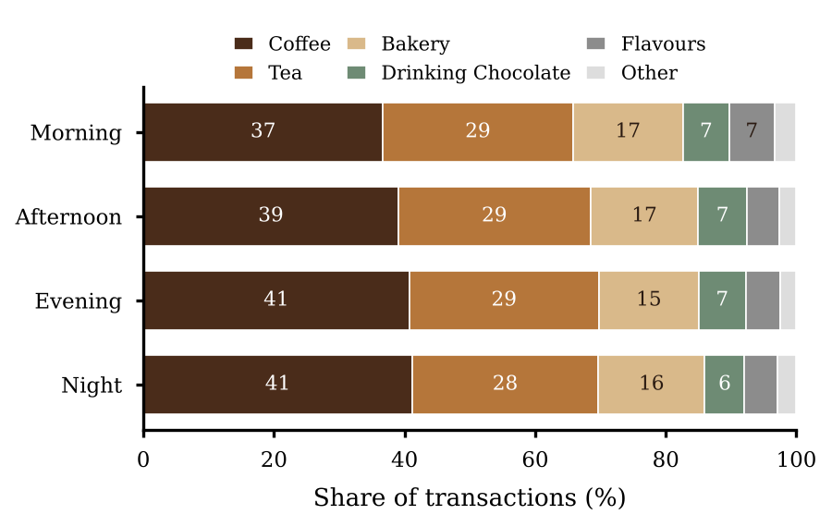
Figure 4. Share of Product Categories in Each Time Segment (%)

Menu Category Prediction
Table 2 compares the classifiers with the baselines. The feature space has only 105 distinct combinations (15 hours × 7 days), and coffee is the most frequent category in 97 of them, tea in the other eight. A baseline that predicts the most frequent category of each hour-day combination therefore reaches 38.11% accuracy, no better than the majority baseline of 38.10%. KNN with K = 20, the value used in the application, reaches 35.31% accuracy (95% confidence interval by date: 34.28 to 36.27), which is 2.78 points below the majority baseline (difference −3.65 to −1.98). On the temporal split the result is the same, 35.25% against 38.79%. KNN predicts only three of the nine categories. Branded items, coffee beans, drinking chocolate, flavours, loose tea, and packaged chocolate are never predicted. Its macro F1-score of 9.17% is higher than that of the other models (6.13% to 6.18%) only because it spreads its predictions over more classes, not because it is more accurate. For top-3 category recommendation, KNN includes the true category in 77.83% of cases, below the 83.73% obtained by always recommending the three most frequent categories. The decision tree, random forest, naive Bayes, and logistic regression all stay within 0.01 points of the majority baseline on the random split, because they predict coffee almost always.
Table 2. Product Category Classification (%). R = Random 80:20 Split; T = Temporal Split (Training on January-May, Test on June); Acc = Accuracy; F1 = Macro F1-Score
Model | Acc R | F1 R | Top-3 R | Acc T | F1 T
Majority baseline | 38.10 | - | - | 38.79 | -
Hour-day mode baseline | 38.11 | - | - | 38.65 | -
Top-3 popular baseline | - | - | 83.73 | - | -
KNN (K = 20) | 35.31 | 9.17 | 77.83 | 35.25 | 8.97
Decision tree | 38.11 | 6.18 | 83.71 | 38.65 | 6.36
Random forest | 38.11 | 6.18 | 83.72 | 38.65 | 6.36
Naive Bayes | 38.10 | 6.13 | 83.73 | 38.79 | 6.21
Logistic regression | 38.10 | 6.13 | 83.73 | 38.79 | 6.21

Figure 5 shows why no value of K helps. Accuracy rises with K and reaches the majority baseline (38.10%) at K ≥ 600, where the model simply predicts coffee. Macro F1-score falls from 10.9% at K = 1 to 6.1% at K = 600, and K = 1 gives a test accuracy of only 28.18%. The two criteria disagree because the features carry no useful signal, and K = 20 lies between the two extremes. When K was selected again from January to May only, accuracy again chose K = 800 (38.79%, equal to the June majority baseline) and macro F1-score chose K = 1 (29.12%). Handling the class imbalance did not help either. Oversampling the training data lowered the accuracy of KNN to 16.65%, and class weighting lowered the accuracy of the decision tree and random forest to about 4% without raising macro F1-score above 3.6%. This is expected: when the features do not separate the classes, rebalancing can only make the model guess rare classes more often.
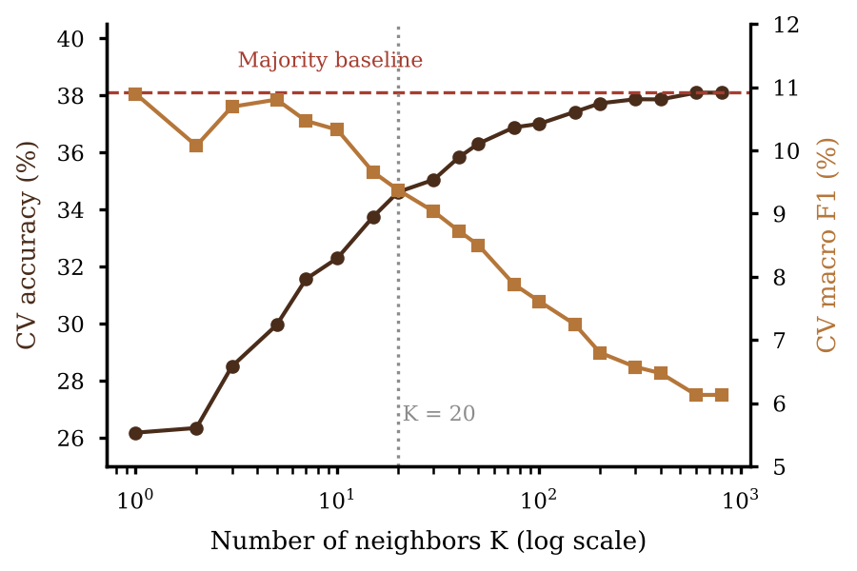
Figure 5. Cross-Validated Accuracy and Macro F1-Score of KNN for Different Values of K

Crowd Prediction
Table 3 shows the regression results. On the random split, KNN (K = 17) reaches a mean absolute error (MAE) of 6.15 transactions per hour and an R² of 0.617, better than the hourly-mean baseline (7.42 and 0.417). The difference of −1.27 is clear (95% interval by date: −1.82 to −0.68), but the decision tree (6.29) and random forest (6.37) are almost as good, so KNN is not special. A random split mixes the months, so the neighbors of a test record often come from the same month. The temporal split removes this advantage. When the models are trained on January to May and tested on June, KNN (K = 24) has an MAE of 8.72 and an R² of 0.495, while the last-month baseline, which only uses the mean count of each hour in May, has 8.14 and 0.578. The difference of +0.58 (interval +0.16 to +0.95) means that KNN is worse than this simple baseline. The random forest (8.81) and the decision tree (9.10) are also worse. Figure 6 shows the reason. The predictions of KNN stop at 49 transactions per hour, whereas the actual counts reach 85, because KNN can only return values that resemble its training data and the volume kept rising (27.7 per hour in May, 30.1 in June).
Table 3. Crowd Regression (Transactions per Hour). R = Random Split; T = Temporal Split; FC = Mean MAE of Forward Chaining over Test Months March-June
Model | MAE R | R² R | MAE T | R² T | MAE FC
KNN | 6.15 | 0.617 | 8.72 | 0.495 | 7.68
KNN without month | 7.68 | 0.366 | 12.13 | 0.074 | 9.42
Decision tree | 6.29 | 0.583 | 9.10 | 0.432 | 7.72
Random forest | 6.37 | 0.591 | 8.81 | 0.509 | 7.69
Hourly-mean baseline | 7.42 | 0.417 | 11.93 | 0.111 | 9.25
Last-month baseline | - | - | 8.14 | 0.578 | 7.39

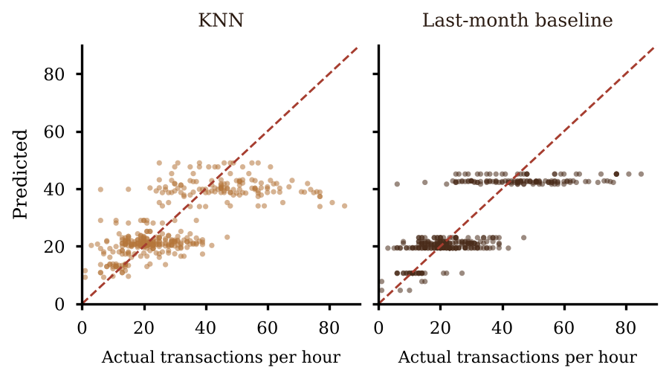
Figure 6. Actual and Predicted Transactions per Hour in June (Temporal Split)

The month feature explains most of what the models learn. Without it, KNN reaches an MAE of 12.13 and an R² of 0.074 on June, which is no better than the hourly-mean baseline (11.93 and 0.111). Forward chaining confirms the picture (Figure 7). The last-month baseline has the lowest MAE in each of the four test months, with a mean of 7.39 against 7.68 for KNN, 7.69 for the random forest, and 7.72 for the decision tree. The learned models are close to each other, and none of them beats the baseline that follows the latest level.
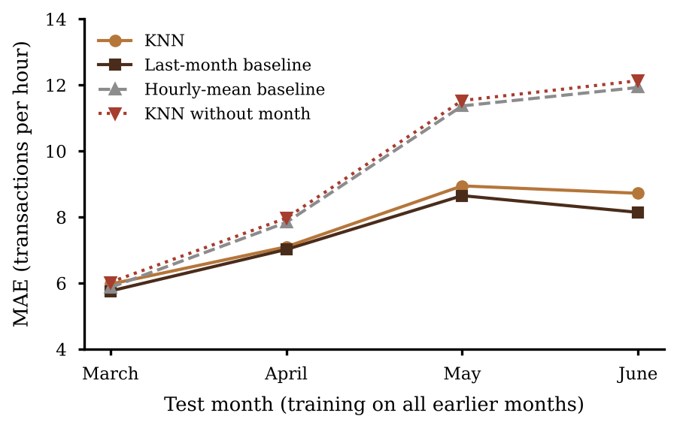
Figure 7. MAE of Forward Chaining for Each Test Month

The analysis uses only the date-hour slots with at least one transaction (2,256 of the 2,715 possible slots). The empty slots are concentrated at 19.00 and 20.00, which are empty on 165 of the 181 days (91.2%), and at 06.00 (89 days), while hours 13.00 to 18.00 are empty on 6 to 8 days each and hours 07.00 to 12.00 are never empty. Hours 19 and 20 therefore appear on only 16 days. The data do not state the opening hours, so an empty slot may mean a closed shop, a missing record, or a quiet hour. As a sensitivity check, all empty slots were filled with zero. KNN then has an MAE of 9.03 and the last-month baseline 8.35, a difference of +0.69 (interval +0.30 to +1.07), which gives the same conclusion.
Crowd Level Classification
Table 4 shows the classification of each hour as quiet, moderate, or busy, using the first and third quartiles of the training counts as thresholds (11 and 28 transactions per hour for the random split, 10 and 26 for the temporal split). On the random split, KNN (K = 15) reaches 67.04% accuracy (95% interval by date: 62.14 to 71.49) and a macro F1-score of 65.96%, clearly above the majority baseline (52.65%) and the baseline that predicts the most frequent class of each hour (58.63% and 56.07%). On the temporal split, however, the advantage disappears. KNN has 72.53% accuracy against 73.33% for the hour-mode baseline, and its macro F1-score is 57.31% against 65.93%. In forward chaining the mean accuracy is 69.11% against 71.42% and the mean macro F1-score 60.03% against 66.03%. The volume rose through the months, so only 26 of the 375 test hours in June are quiet, and the rule that learns the typical class of each hour handles the shift better. The advantage on the random split reflects the mixing of months and is not evidence that KNN predicts the crowd level of future periods.
Table 4. Three-Class Crowd Classification (%). R = Random Split; T = Temporal Split; FC = Mean of Forward Chaining; Acc = Accuracy; F1 = Macro F1-Score
Model | Acc R | F1 R | Acc T | F1 T | Acc FC | F1 FC
Majority baseline | 52.65 | 23.00 | 44.00 | 20.37 | 44.36 | 20.48
Hour-mode baseline | 58.63 | 56.07 | 73.33 | 65.93 | 71.42 | 66.03
KNN (K = 15) | 67.04 | 65.96 | 72.53 | 57.31 | 69.11 | 60.03
Decision tree | 66.15 | 66.65 | 71.47 | 58.71 | 69.32 | 62.21
Naive Bayes | 58.85 | 59.32 | 71.47 | 65.26 | 67.67 | 62.76
Random forest | 65.93 | 65.48 | 72.53 | 59.90 | 68.91 | 60.50

Discussion
The results answer the two research questions differently. The menu a customer chooses is almost independent of the time of day in this dataset, so a time-based KNN has little to learn, and every model ends at or below the majority baseline. The number of transactions per hour depends strongly on the hour and the month, but the learned models do not beat a rule that repeats the latest level. This does not make the recommendation useless in itself. (Panwar et al. 2024) report gains from time-aware recommendation, but for the ratings of individual users, which is a different task and needs user histories that the dataset lacks. The present result rather confirms the warning (Hidasi and Czapp 2023) that offline evaluation can mislead. Accuracy alone would suggest that KNN works for crowd classification, and only the comparison with baselines and the temporal split show that it does not.
For the application, the findings suggest a practical order of preference. A popularity baseline that recommends the three most frequent categories obtains an 83.73% top-3 category hit rate and is better than KNN at the category level. This figure comes from the category evaluation and does not measure the fallback of the application, which selects up to five popular items of the current time segment. Whether the fallback is better would need an item-level evaluation. The crowd label should be read as an estimate of the usual level of the current hour and month, and it needs to be updated as the volume changes. The KNN pipeline remains useful as a framework that can be retrained and compared with the baselines once real transactions are available, because a real shop may show a stronger link between time and menu than this dataset.
Several limits apply. The dataset is simulated (Figueira and Vaz 2022), and the lack of dependence between time and category may be a property of the simulation and not of coffee shops. Only one branch and six months were used, which is too short to separate a trend from seasonality. The data have no opening hours and no customer or basket identifiers. The only features are the hour, the day, and the month. The evaluation is offline and covers categories, not individual items, so the study does not show the quality of item ranking, whether customers accept the recommendations, or how they affect orders. The crowd model uses the month as a feature and was trained only on January to June, so its predictions for other months are not validated, although the application uses the current calendar month. These limits point to the next steps: real transactions from a longer period, features such as holidays and weather, models that can follow a trend, and a test with live users.

CONCLUSIONS AND SUGGESTIONS
Conclusion
This study designed a time-based menu recommendation and an hourly crowd prediction for Lower Manhattan Coffee Shop. They are built on K-Nearest Neighbor, a Flask service, and a CodeIgniter 4 ordering application with a rule-based fallback, and they were evaluated against simple baselines on 47,782 transactions of a simulated dataset. The evaluation does not support the claim that KNN improves the menu recommendation.
First, time explains the product category only negligibly (Cramér's V = 0.034). KNN with K = 20 reached 35.31% accuracy, below the majority baseline of 38.10%, predicted only three of the nine categories, and had a top-3 category hit rate (77.83%) below that of the three most frequent categories (83.73%). Second, the hour and the month explain the number of transactions per hour well. KNN regression was better than the hourly mean on a random split (mean absolute error 6.15 against 7.42), but on June, which the model had not seen, a baseline that repeats the hourly mean of the previous month was better (8.14 against 8.72), and it was also the best in each of the four forward-chaining months. Third, KNN classified three crowd levels better than the baselines on a random split (67.04% accuracy) but not on a temporal split (macro F1-score 57.31% against 65.93%). These conclusions hold for this fictitious-shop dataset, one branch, and six months, and for an offline evaluation of categories; item ranking, user acceptance, and the effect on customers remain untested.
Suggestion
For the application, the popularity-based fallback can remain the default menu recommendation until an item-level evaluation shows that KNN is better, and the crowd label should be shown as an estimate that is refreshed when the volume changes. For future research, we suggest (1) training and testing the pipeline on real transactions from a longer period with known opening hours, (2) adding features such as holidays, weather, and promotions, (3) comparing models that follow a trend, such as time series models, with the last-month baseline, and (4) testing the recommendations with live users, for example by comparing the selection rate of recommended items with a control group, using the recommendation logs that the application already stores.

REFERENCES

Allorerung, P. P., Erna, A., Bagussahrir, M., & Alam, S. (2024). Analisis performa normalisasi data untuk klasifikasi K-Nearest Neighbor pada dataset penyakit. JISKA (Jurnal Informatika Sunan Kalijaga), 9(3), 178-191. https://doi.org/10.14421/jiska.2024.9.3.178-191
Arisandi, D., Sutanto, K., & Perdana, N. J. (2024). Implementasi aplikasi pemesanan pada Life & Story Coffee untuk digitalisasi pencatatan pesanan. Panrita Abdi - Jurnal Pengabdian pada Masyarakat, 8(3), 686-693. https://doi.org/10.20956/pa.v8i3.26742
Bogina, V., Kuflik, T., Jannach, D., Bielikova, M., Kompan, M., & Trattner, C. (2023). Considering temporal aspects in recommender systems: A survey. User Modeling and User-Adapted Interaction, 33(1), 81-119. https://doi.org/10.1007/s11257-022-09335-w
Bondevik, J. N., Bennin, K. E., Babur, Ö., & Ersch, C. (2024). A systematic review on food recommender systems. Expert Systems with Applications, 238, 122166. https://doi.org/10.1016/j.eswa.2023.122166
Chow, Y. Y., Haw, S. C., Naveen, P., Anaam, E. A., & Mahdin, H. (2023). Food recommender system: A review on techniques, datasets and evaluation metrics. Journal of System and Management Sciences, 13(5). https://doi.org/10.33168/JSMS.2023.0510
Figueira, A., & Vaz, B. (2022). Survey on synthetic data generation, evaluation methods and GANs. Mathematics, 10(15), 2733. https://doi.org/10.3390/math10152733
Hafid, H. (2023). Penerapan K-fold cross validation untuk menganalisis kinerja algoritma K-Nearest Neighbor pada data kasus Covid-19 di Indonesia. Journal of Mathematics Computations and Statistics, 6(2), 161-168. https://doi.org/10.35580/jmathcos.v6i2.53043
Hidasi, B., & Czapp, Á. T. (2023). Widespread flaws in offline evaluation of recommender systems. In Proceedings of the 17th ACM Conference on Recommender Systems (RecSys '23). Singapore: ACM.
Hssina, B., Grota, A., & Erritali, M. (2021). Recommendation system using the k-nearest neighbors and singular value decomposition algorithms. International Journal of Electrical and Computer Engineering, 11(6), 5541-5548. https://doi.org/10.11591/ijece.v11i6.pp5541-5548
Maven Analytics. (n.d.). Coffee Shop Sales [Data set]. Maven Analytics Data Playground. Retrieved November 4, 2026, from https://mavenanalytics.io/data-playground/coffee-shop-sales
Mellany, J. S., & Kusnawi, K. (2026). Hybrid food recommendation system using term frequency-inverse document frequency (TF-IDF), K-nearest neighbors (KNN), and tag-based similarity. AVITEC, 8(1), 151-161. https://doi.org/10.28989/avitec.v8i1.3683
Meng, X., Du, Y., Zhang, Y., & Han, X. (2022). A survey of context-aware recommender systems: From an evaluation perspective. IEEE Transactions on Knowledge and Data Engineering. Advance online publication. https://doi.org/10.1109/tkde.2022.3187434
Nafi, T. M., & Mujiyono, S. (2025). Aplikasi rekomendasi menu makanan harian menggunakan algoritma metode KNN. Jurnal Algoritma, 22(2), 381-388. https://doi.org/10.33364/algoritma/v.22-2.2491
Panwar, M., Sharma, A., Mahela, O. P., Khan, B., & Ali, A. (2024). An intelligent time aware food recommender system using support vector machine. Indonesian Journal of Electrical Engineering and Computer Science, 34(1), 620-629. https://doi.org/10.11591/ijeecs.v34.i1.pp620-629
Pratama, R. K., & Mandita, F. (2024). Klasifikasi penerimaan tenaga kerja tertutup menggunakan algoritma K-Nearest Neighbor (KNN). Indexia, 6(1), 42-61. https://doi.org/10.30587/indexia.v6i1.7224
Pratama, Y. C. A., & Dewi, C. (2025). Analysis of consumer purchasing patterns using the Apriori algorithm on sales transaction data from Anak Panah Kopi Salatiga. International Journal Software Engineering and Computer Science, 5(1), 1-10. https://doi.org/10.35870/ijsecs.v5i1.3275
Rizki, A. P., Auliasari, K., & Rudhistiar, D. (2024). Sistem rekomendasi penentuan paket menu menggunakan algoritma Apriori (studi kasus: IFF Ayam Uleg Cak Abit Cabang Bendungan Sutami). JATI (Jurnal Mahasiswa Teknik Informatika), 8(2), 1289-1297. https://doi.org/10.36040/jati.v8i2.9094
Salam, R. N., Dahliyanti, N., & Yel, M. B. (2026). Implementation of a website-based QR menu and self-ordering system at Warkop Abas. International Journal Software Engineering and Computer Science, 6(3), 1039-1045. https://doi.org/10.35870/ijsecs.v6i3.8325
Sari, N., Hananto, A., Priatna, B., & Hilabi, S. S. (2025). Implementasi algoritma K-NN untuk klasifikasi penjualan menu terlaris di RM Ratu Chaniago. JIKA (Jurnal Informatika), 9(3), 339-346. https://doi.org/10.31000/jika.v9i3.14445
Suherlan, E., Arti, S., Nabilah, S., & Hazimah, Z. (2025). Penerapan Flask framework untuk deployment model machine learning dalam mendukung analisis adaptasi mahasiswa pada pembelajaran daring. PINTER: Jurnal Pendidikan Teknik Informatika dan Komputer, 9(1), 110-117. https://doi.org/10.21009/pinter.9.1.15
Taslim, T., Gumanti, A. E., Handayani, S., & Toresa, D. (2022). Penerapan algoritma K-Nearest Neighbor untuk klasifikasi topik skripsi mahasiswa di Fakultas Ilmu Komputer. JITACS: Journal of Information Technology and Computer Science, 1(2), 45-50. https://doi.org/10.31849/jitacs.v1i2.10037

